MSE803: Data Analytics
Assessment 1: Theory Exam
Avon River Environmental Data Analysis

Field | Details
Student Name | Saurabh Singh
Student ID | 270732411
Course | MSE803 Data Analytics
Assessment | Assessment 1 Theory Exam
Lecturer | Mohammad Norouzifard
Submission Date | June 2026

Contents
1. Introduction 3
2. Task 1: Avon River Environmental Data Analysis 4
2.1 Task 1-A: Problem Identification 4
2.2 Task 1-B: Data Analysis Techniques 7
2.3 Task 1-C: Tool Selection and Visualisation 9
2.4 Task 1-D: Decision Making and Recommendations 13
3. Task 2: Critically Evaluating Data Analytic Strategies 14
3.1 Task 2-A: Critically Evaluate Data Analytic Strategies 14
3.2 Task 2-B: High-Level Thinking and Recommendations 17
4. Conclusion 20
5. References 21

1. Introduction
Monitoring water quality and fish population assessments are two activities that are strongly linked together and can provide a picture of the health of fresh water ecosystems to environmental managers and policy makers. Data from this report is taken from the Avon River data set, which was collected over three monitoring sites (AV-1, AV-2, and AV-3) between October and December 2023. The data includes the water quality information (temperature, pH, dissolved oxygen) and also fish population information (number of fish species, average body size). With the effects of climate change, changes in land use, and pollution on freshwater systems growing across the globe, the need to monitor these systems is more critical than ever, as noted by Kaushal et al. (2021).
This assessment report has two main objectives. Task 1 will be analysing the Avon River data to identify environmental issues, providing the proper analytical tools, and making data based recommendations for managing the Avon River.Task 1 will involve analysing the Avon River data to identify environmental issues, provide the appropriate analytical tools and make data based recommendations for the management of the Avon River. The second (Task 2) requires students to analyse the data analytics strategies in two business scenarios: an AI based customer relationship management (CRM) system and a user experience (UX) improvement project with the use of A/B testing.
This report is intended to show that data can be utilized to help improve environmental and business decisions, and is designed to be shared as a first year post-graduate student in data analytics. The analysis is provided based on data values which are uploaded and academic literature.

2. Task 1: Avon River Environmental Data Analysis

2.1 Task 1-A: Problem Identification
By examining the Avon River dataset carefully, two major environmental challenges stand out as having a measurable and concerning impact on the river's fish populations. These are rising water temperatures and declining dissolved oxygen levels at specific sites and time periods. Both of these factors are well-documented in environmental science literature as critical stressors for freshwater fish communities (Chessman, 2013).
Challenge 1: Elevated Water Temperatures
The temperature of the water is one of the most critical physical factors affecting the survival and growth of freshwater fishes. There is significant variation between the monitoring sites for the Avon River data. Sites AV-3 had some of the highest temperatures in the dataset, with a temperature of 21.0°C recorded once during December 2023, and the mean temperatures were well above temperatures recorded at AV-1. The temperatures at AV-1 were always lower, in the range of 13.2°C to 16.2°C in October and November and around 18.9°C in December. AV-3 however, consistently recorded temperatures over 18°C in November and December, and several occasions in December recorded temperatures over 20°C.
This is significant for the fish species in the data set. For instance, Brown Trout (Salmo trutta) are known to be cold-water specialists and show physiological stress at a sustained temperature over around 18-20°C (Elliott & Elliott, 2010). The data do show Brown Trout at AV-3, but the average numbers of fish seen at AV-3 (approx. 13.9 fish per observation) are not drastically different to those seen at AV-2 (approx. 10.1 fish per observation), indicating that heat sensitive species may already be encountering sub-optimal conditions at the warmer AV-3. The relationship between temperature/ fish population is more evident for the smaller, more cold-tolerant species like Inanga. High numbers of Inanga (Galaxias maculatus) were noted at AV-3, a site with warmer temperatures, but probably this is an indication of their liking of slower, more water temperature than cold water. The overall stability of the sizes and numbers of fish, however, as temperatures approach the ranges reported in the literature, is of concern.
A data analytics perspective of the ability to measure temperature over time and at multiple sites is an early warning system. The dataset will be useful to look for future changes in the dataset if temperatures continue to rise as climate models predict for freshwater systems in New Zealand (Ministry for the Environment, 2022).

Site | Min Temp (°C) | Max Temp (°C) | Mean Temp (°C) | Key Observation
AV-1 | 13.4 | 19.4 | 14.7 | Coolest site; most stable
AV-2 | 14.6 | 20.7 | 15.9 | Moderate temperatures
AV-3 | 13.2 | 21.0 | 17.8 | Warmest site; December spikes
Table 1: Water Temperature Summary by Site
Challenge 2: Declining Dissolved Oxygen at Specific Sites
Dissolved oxygen (DO) is the oxygen found in water that is dissolved in the water and is critical for all aquatic life. Most healthy, temperate freshwater streams would be expected to have DO concentrations of greater than 7.0 mg/L (7.0 ppm) (Ministry for the Environment, 2020) which is the level required for the fish to breathe through their gills. In the case of the Avon River data, several readings are at or below this threshold, especially at the stations AV-1 and AV-3 during certain periods.
At AV-1 there are several readings that are either just over or just under 7.0 mg/L, such as 6.9 on 27 October 2019, 6.8 on 24 October 2019, and 6.9 on 8 October 2019. These are not critical lows but times of reduced oxygen levels that may stress sensitive species. Similar trends can be seen at AV-3 where a DO reading of 6.5 mg/L was obtained on 12 November and 6.7 mg/L in both December readings for AV-3. AV-2 was slightly more consistently higher than the 7.0 mg/L threshold with some readings being of 8.5-9.2 mg/L, indicating better oxygenation at this site.
The dissolved oxygen levels are affected by the temperature of the water (warmer water has less oxygen), break down of organic matter, the activity of algae, and movements of water. This dataset supports a well known inverse relationship between temperature and dissolved oxygen solubility (Ficklin et al., 2013) as the pattern of higher temperatures and some lower DO levels were evident. This double blow might be particularly harmful in the long-term for fish stocks.
Fish data was extremely sparse: Some sites and times had only a few or very few Longfin Eel (Anguilla dieffenbachii) (a few as low as 3). There are several factors that affect eel population counts, but periods of low DO correlate with a decreased feeding activity and impaired immune system in eels (Chessman, 2013). Data analytics allows us to connect these blips in water quality to population fluctuations in the area, and determine when and where action is needed.

Site | Min DO (mg/L) | Max DO (mg/L) | Mean DO (mg/L) | Readings Below 7.0 mg/L
AV-1 | 6.8 | 9.0 | 7.8 | 3 readings
AV-2 | 6.7 | 9.1 | 8.2 | 2 readings
AV-3 | 6.5 | 9.2 | 7.8 | 4 readings
Table 2: Dissolved Oxygen Summary by Site
How Data Analytics Addresses These Challenges
These problems are met in a variety of interconnected, and ever more powerful, ways with data analytics. On the most fundamental level, structured data collection over time provides managers with information on trends and anomalies not available to them from field observation. If it's just one reading in October that goes above 18-21°C, at AV-3 it may be considered the season. But if it's multiple readings across October, November, and December 2023 that all stay hotter than 18-21°C, then it's undeniable — and analytics makes it visible.
As well as detecting, analytical methods like correlation analysis and regression modelling can indicate which water quality parameters are most likely to cause a reduction in fish condition. For this dataset, managers can detect that dissolved oxygen levels are consistently dropping close to the 7.0 mg/L limit at two locations (AV-1 and AV-3) and that these times of low DO correspond to increases in temperature, and take proactive measures. The organisation could program in automatic threshold alarms instead of waiting for a fish kill or a significant drop in population before it investigates: If the water temperature at AV-3 is at or above 19°C for 3 or more successive readings, a targeted field inspection is scheduled. Only systematic collection and continuous analysis of data can allow the implementation of this type of early warning system (Kaushal et al., 2021).
Finally, visualisations deliver complex multi-variable data into a clear and accessible communication with non-technical audiences like local councils, community groups, and funding bodies. The case for planting riparian vegetation or flow management is much stronger when a chart graphically illustrates how dissolved oxygen at AV-3 declines below the safety level as temperatures rise. Data analytics thus serves two purposes: It improves the scientific understanding of the problem and It strengthens the argument for social and political action.

2.2 Task 1-B: Data Analysis Techniques
To address the two environmental challenges identified in the previous section, two analytical techniques are proposed: Correlation Analysis and Trend Analysis. Both techniques are well-suited to the structure of the Avon River dataset and can be applied with commonly available tools.
Technique 1: Correlation Analysis
The statistical technique that quantifies the direction and magnitude of the relationship between two numeric variables is called correlation analysis. The correlation coefficient (usually r) is determined, which is between -1.0 and +1.0. A value near +1 means that the variables tend to move in the same direction, and a value near -1 means that they tend to move in opposite directions. Values close to 0 indicate low or weak linear relationships. Salkind (2016) states that one of the most widely used tools in environmental sciences are the correlation analysis as it is an efficient way to summarise the co-variation of the variables.
Correlation analysis is especially useful for the Avon River data set as it allows for quantification of the relationships between water quality parameters (e.g., temperature, pH, dissolved oxygen) and fish population outcomes (e.g., fish count and average fish size). When the two datasets are combined together, the resulting analysis shows that there is a negative correlation between temperature and average fish size of about -0.15, meaning that there is a slight, but definite negative correlation: As temperature goes up, average fish size goes down. More importantly, there is a strong inverse relationship between the fish count and the average size, with a correlation of about -0.66; sites or dates with more fish having a smaller average size, where Inanga is seen as having a higher presence in the small fish size classes.
Step-by-Step Implementation
- Step 1: Load the water quality and fish population datasets from the Excel file into a data analysis tool such as Microsoft Excel or Python.
- Step 2: Merge the two datasets on the shared Site ID and Date fields to create a single combined table.
- Step 3: Calculate Pearson correlation coefficients between each pair of variables (e.g., temperature vs. count, DO vs. average size, pH vs. count).
- Step 4: Create a correlation matrix to display all pairwise relationships at once.
- Step 5: Identify the strongest relationships and interpret what they mean for river health.
- Step 6: Report the findings with supporting scatter plots to communicate visually.

This technique is expected to confirm that lower dissolved oxygen readings are associated with lower fish counts at certain sites, and that higher temperatures correspond with certain species composition shifts. These insights directly inform management decisions.
Technique 2: Trend Analysis
Trend analysis is a technique which looks at the sequence of values of a variable over time to detect a trend, either increasing, decreasing or cyclic. Trend analysis is widely applied in environmental science to identify long-term trends of environmental quality deterioration or improvement (e.g., water quality or biodiversity indices) (Harrell, 2015). A simple trend analysis consists of graphing a variable against time, then fitting a simple regression line or moving average to the data to help understand the direction of the trend.
The study period for the Avon River dataset is from early October through late December 2023, a total of about three months worth of data. A trend analysis of the data at each site can provide an indication of whether or not DO is decreasing as temperatures rise during the summer, a trend that is ecologically significant as the data covers the spring into early summer in NZ. Counting fish, like counting people, also over time can show you if fish numbers are going up (fish are more active in spring), staying the same or going down (possibly due to declining water quality).
Step-by-Step Implementation
- Step 1: Sort the dataset by date within each site grouping.
- Step 2: For each site (AV-1, AV-2, AV-3), plot dissolved oxygen and temperature values on a time series chart.
- Step 3: Add a linear trend line to each series to determine if the variable is increasing or decreasing over the period.
- Step 4: Repeat for fish count data per site, noting changes in total count across the weeks.
- Step 5: Identify periods where DO drops coincide with increases in temperature, which would support the mechanistic explanation for declining oxygen.
- Step 6: Annotate charts with key observations and share with stakeholders.

The expected insight from trend analysis is that AV-3 shows a gradual increase in temperature through November and December, accompanied by a slight downward trend in dissolved oxygen. If fish counts at AV-3 also decline during the same period, this would build a convincing multi-variable case for environmental stress at that site.

2.3 Task 1-C: Tool Selection and Visualisation
Choosing the right analytical tool is an important step in any data analytics project. The choice depends not only on the technical capabilities of the tool but also on the skills of the user, the size of the dataset, and the type of outputs required. For this project, two tools are recommended: Microsoft Excel and Python (with the pandas and matplotlib libraries).
Tool 1: Microsoft Excel
Strengths: Microsoft Excel is extremely widely used, and has an intuitive interface that's accessible even to users who aren't a programmer. It has an embedded Data Analysis ToolPak that provides access to a variety of chart types, pivot tables, descriptive statistics and correlation tools. If the data set is small, such as the Avon River data (71 rows), Excel would be adequate for the computational needs. The Excel spreadsheets are also easily shared, so that results can be passed on to fellow employees or supervisors. Excel is still one of the top analysis tools used in government and environmental organisations because it is user friendly, according to Walkenbach (2015).
Limitations: Excel does not work well with very large data sets. It is also not reproducible: If the formula was accidentally deleted, the analysis may be incomplete without a clear audit trail. There is no native support with advanced statistical procedures like machine learning or complex regression modelling. It is also more difficult to automate, and to work in a batch-processing mode over several datasets, than in a programming environment.
Programming Excel: Excel is a great tool to start with as it's moderate size and the organisation may not have data scientists on board. It enables staff to undertake the fundamental analysis and create professional presentations without having to master coding. Importantly, Excel directly supports both of the analytical techniques selected in Section 2.2: the built-in Data Analysis ToolPak can be used to calculate the Pearson correlation between all the water quality and fish population variables, meeting Technique 1 (Correlation Analysis); and Excel's line chart function with overlay trendline is powerful enough to meet Technique 2 (Trend Analysis) — managers can easily visualize how dissolved oxygen and temperature changed throughout the study period (October–December) without writing another formula manually.
Tool 2: Python (pandas and matplotlib)
Strengths: Python is open source, free, and is the primary language in data science and analytics (VanderPlas, 2016), which is a strength. The pandas library is used to load, clean and transform tabular data, and matplotlib and seaborn are used to produce quality customisable visualisations. The Python analysis script is very reproducible: as long as the data is changed, the analysis can be run again and the same results will be obtained. Python can also easily scale to considerably larger data sets.
Limitations: Python takes time to learn compared with Excel, particularly to people who have never programmed before. Some technical knowledge is required to set up the development environment (installation of python, jupyter notebook and necessary libraries). In case of one-off analyses, you might need more time to learn Python than to just open Excel.
Python is the more appropriate language for creating the reproducible and automated analysis outlined in this report, particularly for this dataset, which will probably be updated frequently with new readings. It also facilitates very easy implementation of more advanced techniques like correlation matrices, trend line fitting, and multi-site comparison charts, after the initial coding. Python's scipy.stats library includes a single function that calculates the whole Pearson correlation matrix for technique 1: all pairwise relationships between temperature, pH, dissolved oxygen, fish count and average fish size are calculated at once. Matplotlib, a Python library, creates publication-quality time-series charts that are much more than what Excel's chart builder can do, and Technique 2 focuses on making these kinds of charts. As the monitoring programme at the Avon River expands, Python becomes the language of choice for the future.

Feature | Microsoft Excel | Python (pandas/matplotlib)
Ease of use | High — familiar to most users | Moderate — requires coding knowledge
Cost | Licensed (often already available) | Free and open-source
Dataset size | Suitable for small–medium data | Suitable for any size
Reproducibility | Low — manual steps | High — script-based
Visualisation quality | Good — standard charts | Excellent — highly customisable
Advanced statistics | Limited | Extensive library support
Table 3: Tool Comparison — Microsoft Excel vs Python
Visualisations
The following four visualisations were generated from the actual uploaded Avon River dataset values using Python. Each chart is designed to communicate a different aspect of the environmental story told by the data.
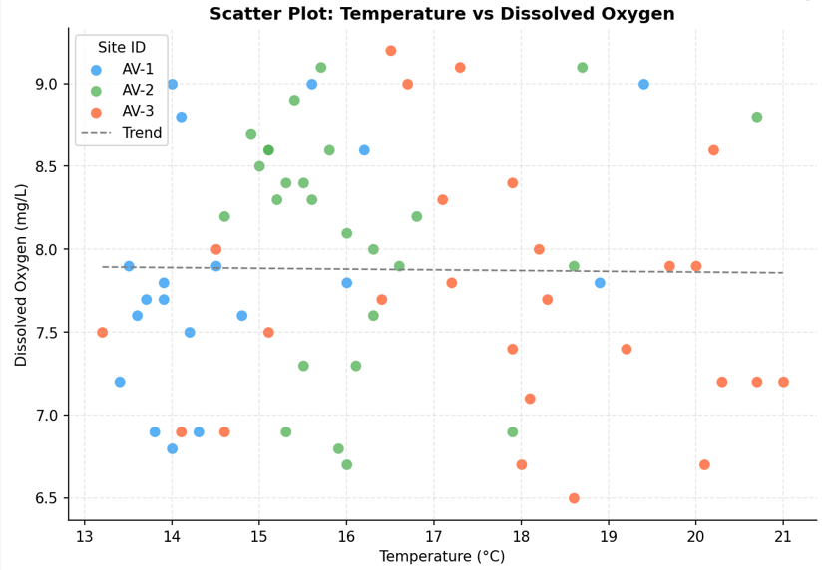
Figure 1: Scatter Plot
This chart explores the relationship between water temperature and dissolved oxygen levels across the three monitoring sites (AV-1, AV-2, AV-3). Each point represents a single observation, colour-coded by site. The dashed trend line reveals a slight inverse relationship — as temperature rises, dissolved oxygen tends to decrease, which is consistent with known water chemistry behaviour.
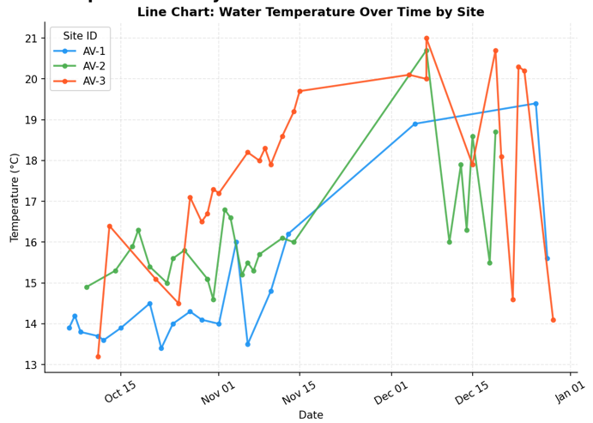
Figure 2: Line Chart
This chart tracks how water temperature changed at each site between October and December 2023. AV-3 consistently records the highest temperatures and shows the steepest upward trend over time, while AV-1 remains the coolest site throughout the monitoring period. The chart highlights clear seasonal warming across all three locations as summer approaches in New Zealand.
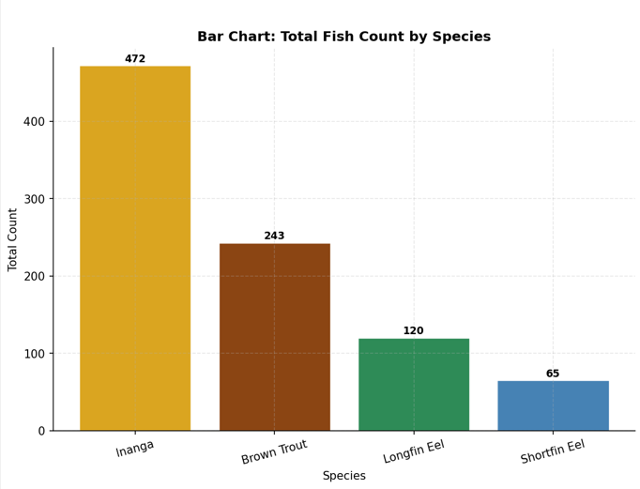
Figure 3: Bar Chart
This chart summarises the total number of fish recorded across all sites and dates, grouped by species. Inanga dominates with the highest overall count, reflecting its abundance as a native galaxiid in the river system. Brown Trout and the two eel species (Shortfin and Longfin) appear in comparatively lower but relatively similar numbers.
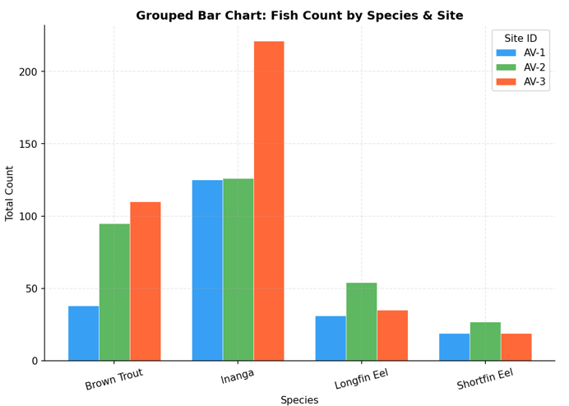Figure 4: Grouped Bar Chart
This chart breaks down fish counts by both species and monitoring site, allowing direct comparison across locations. It reveals that Inanga sightings are concentrated at AV-1 and AV-3, while Brown Trout appear more evenly distributed. The eel species tend to be recorded in smaller numbers at all three sites, with some variation between Shortfin and Longfin distributions depending on location.

2.4 Task 1-D: Decision Making and Recommendations
Based on the analysis of the Avon River dataset, two practical and data-driven recommendations are proposed to address the identified environmental challenges. Each recommendation is directly linked to evidence from the dataset and is grounded in established freshwater management practices.
Recommendation 1: Implement Riparian Shade Management at Site AV-3 to Reduce Water Temperature
The data clearly shows that AV-3 consistently had the highest water temperature of the three monitoring sites, with water temperatures reaching 21.0°C in December 2023. This is nearing the upper thermal tolerance limit for Brown Trout, an ecologically and recreationally significant species (Elliott & Elliott, 2010). The trees and shrubs growing on the river banks (riparian vegetation) are important to shade the water surface and decrease the amount of heat absorbed in the summer season. The planting of riparian plants has been shown in New Zealand to lower stream temperatures over time (2-5°C) and the removal of riparian plants has been found to raise temperatures (Ministry for the Environment, 2022).
Recommendation: In the AV-3 catchment, consider planting native riparian vegetation (e.g. kahikatea, flax and native willowherb) along the river bank in consultation with the relevant land management authority. Low cost, long-term intervention with no continuing chemical inputs or mechanical maintenance once established. The collection of data will provide a baseline – if annual monitoring reveals that temperatures at AV-3 are still above 19°C in summer after planting, more action, such as further tree planting upstream will be warranted. This recommendation is achievable as it fits within current programmes undertaken by regional councils for riparian planting in New Zealand (Ministry for the Environment 2022).
Potential environmental impacts: Lowering of peak summer water temperatures at AV-3, and increased dissolved oxygen concentrations (which is beneficial because cooler water contains more oxygen) and habitat improvement for cold water dependent species like Brown Trout and Longfin Eel. Additionally, shading over time will inhibit the growth of algae and stabilize the pH.
Increased fish population health effects: Brown Trout at AV-3 could grow in both numbers and average size with decreased thermal stress. The warmest site has the potential to benefit Longfin Eel, a New Zealand threatened species (Chessman, 2013).
Recommendation 2: Investigate and Address Low Dissolved Oxygen Events at AV-1 and AV-3

There are multiple observations at AV-1 and AV-3 that fall below the 7.0 mg/L limit for dissolved oxygen, specifically at AV-1, during October-November (e.g., 6.8 and 6.9 mg/L) and at AV-3 during November-December (e.g., 6.5 and 6.7 mg/L). These values are not immediately catastrophic but fall in an area of sub-optimal conditions that could negatively affect fish health, especially for Brown Trout, which have higher oxygen requirements (Ficklin et al., 2013).

A targeted investigation of the reasons for the low DO at these locations is recommended. This may be due to the following factors, which can lead to algal bloom decomposition: higher levels of organic matter (agricultural runoff or leaf decomposition), reduced flow rates in dry summers, and algal bloom decomposition. The investigation should include: (1) installation of continuous water quality loggers at AV-1 and AV-3 to record water quality parameters at hourly intervals, not only during monitoring visits; (2) collection of water samples for nutrient analysis (in particular nitrogen and phosphorus which will fuel algal growth); and (3) an evaluation of water flow rates during low-DO periods to determine if reduced flow is a contributing factor. Actions that may be suggested based on the findings of this investigation may involve reducing inputs from upstream fertiliser, implementing features for fish to pass through to maintain water flow, or controlling aquatic plants.

Supporting evidence: There is multiple below-than-threshold DO readings at AV-1 and AV-3, as well as an inverse relationship between temperature and DO, which is apparent in the dataset, that warrants this investigation. The above findings indicate that the DO values at AV-2 are consistently higher than elsewhere, which indicates that the factors are not just seasonal and further investigation is warranted instead of a blanket intervention.

Potential environmental benefits: Assessing and mitigating causes of low DO will help maintain adequate oxygen levels throughout the year, which will help ensure the long-term sustainability of the fish community among all four species in the dataset.

3. Task 2: Critically Evaluating Data Analytic Strategies

3.1 Task 2-A: Critically Evaluate Data Analytic Strategies
This section evaluates data-driven decision-making approaches for two organisational projects. Project A involves the implementation of an AI-powered Customer Relationship Management (CRM) system that uses machine learning to personalise customer interactions and forecast sales opportunities. Project B involves improving user experience (UX) through A/B testing and collection of user feedback to make iterative design improvements to a digital product.
Characteristics of Data-Driven Decision Making
Improved decision quality: One of the most common advantages of data-driven approaches is that they decrease the need for individual intuition and bias in decision making (McAfee and Brynjolfsson, 2012). An AI-powered CRM can analyze thousands of records of customer interactions in Project A and reveal trends in customer purchase behavior that a human sales manager might have missed. It could also show that customers who call support within 30 days of buying are three times more likely to churn, helping to identify strategies to prevent them from doing so. A/B testing, in Project B, is used in place of anecdotal arguments about design choices for creating the empirical evidence. Rather than speculating which is better, the team can simply conduct an experiment with a controlled experiment and wait and see what users do.
Data analytics for evidence-based planning: More rigorous and detailed planning is achieved by using the data to inform plans rather than making assumptions. If the organisation has information on previous orders and market trends, this information may be used for project A to more accurately predict future order levels and better manage resources. In Project B, analysing clickstream data can help to determine where users get lost in the interface, and make improvements to it, not a complete redesign, which can be more expensive (Nielsen, 2012).
Better forecasting: The AI-powered CRM in Project A is based on predictive modelling, which enables companies to anticipate customer needs before they are even expressed. This ability is also known as predictive analytics and has been proven to greatly increase sales conversion rates when done well (Davenport & Harris, 2007). While less noticeable, in Project B, there is a loop of continual improvement through iterative A/B testing, such that every design decision is supported by the sum of all prior evidence collected from testing.
Lower uncertainty: both projects illustrate the benefits of data analytics for lowering the uncertainty in business decisions. The launch of any new product feature or CRM module is always risky, but if previous data suggests that there is a high likelihood of success, as the chances of success of similar past interventions, the management can confidently go ahead with the investment. Especially in competitive settings where expensive errors can have long-term repercussions.
The primary problems with Data-Driven Decision Making are as follows:
Data quality problems: The quality of the analytical results is completely determined by the quality of the data that is collected, as expressed in the saying "garbage in, garbage out. Project A may have duplicate records in CRM, and contact details may be incorrect or customer records may not be properly classified. Such mistakes may lead the AI model to learn the wrong patterns and give wrong recommendations. For Project B, the results of the A/B test may not be valid due to technical issues that cause one or more user segments to have different experiences with the variations, or due to sample contamination in which one user segment sees the variations in both the A and B versions.
Historical data and models: Algorithmic systems such as the AI-CRM in Project A are based on historical data, and if the history includes discriminatory or suboptimal practices then the algorithm will perpetuate that. If, for instance, historically, the sales team has focused on specific customer segments, the AI system may learn to ignore other segments, resulting in a vicious cycle. O'Neil (2016) documents in detail many examples of algorithmic bias that have resulted in harm to persons and communities, illustrating the need to critically explore the nature of the data that a model is learning from.
Model uncertainty – Machine learning models can be very good on the historical training data, but do not perform well on new data examples – this is called overfitting. A CRM model that is trained based on customer behavior before the pandemic could give wrong predictions in a post-pandemic environment. With multiple variations tested at once in Project B, the statistical significance threshold of an A/B test can be misapplied, and give false positive results without appropriate correction (Kohavi et al., 2020).
Privacy issues: Both projects require a lot of personal information to be gathered and analyzed. Customer profiles and purchase histories are sensitive personal information that must be handled appropriately in line with relevant privacy laws, including the Privacy Act 2020 in New Zealand and the EU General Data Protection Regulation (GDPR). For Project B, informed consent and clear communication of the use of clickstream information and feedback forms is required to track individual user actions. Responsible privacy management can lead to regulatory fines and reputation damage.

Comparing Data Types: The two projects have different types of data and an understanding of these differences is crucial to the critical evaluation of the two strategies.
Project A uses customer interaction data, purchase history data, market trend data and CRM behavioural logs. This data is often transactional and structured, such as a sale, support call, contract renewal, etc., that have a clear time and quantity. This is because of the amount of data that the CRM system can store. Over time, a CRM system can collect millions of records, allowing machine learning models to discover subtle patterns. This information is also very sensitive and heavily regulated with regard to privacy. Furthermore, it includes stated or transactional behaviour which may not necessarily reflect the customer sentiment or intent.
Project B includes clickstream logs, A/B testing results, customer satisfaction surveys and usability metrics data relating to user behaviour. This data includes quantitative data (time on page, click-through rate, conversion rate) and qualitative data (open-ended survey responses, verbal feedback from usability testing). The quantitative elements can be analysed at scale, and the qualitative elements give depth and context that can't be captured by numbers. Nielsen (2012) says that the best UX research is a balance of the two, as quant data will tell you what is going on and qual data will tell you why. Project B's data is consequently more explanatory than data from other projects, but also more complex to analyse systematically, because of its mixed methods.

Dimension | Project A (AI-CRM) | Project B (UX/A-B Testing)
Primary data type | Transactional & behavioural (CRM) | Behavioural & attitudinal (UX)
Data volume | Very high (millions of records) | Moderate (thousands of sessions)
Data sensitivity | High — personal financial data | Moderate — user interaction logs
Analysis method | Machine learning, predictive modelling | Statistical testing, thematic analysis
Decision speed | Automated and near-real-time | Iterative and deliberate
Feedback loop | Continuous model retraining | A/B test cycles and releases
Qualitative element | Minimal | Significant (feedback, usability)
Table 4: Comparison of Data Types and Approaches — Project A vs Project B

3.2 Task 2-B: High-Level Thinking and Recommendations

Risks associated with Project A: AI-Powered CRM

Risk 1: Algorithmic Bias and Unfair Targeting

The first risk is Algorithmic Bias and Unfair Targeting.The first risk is Algorithmic Bias and Unfair Targeting. The danger in implementing an AI-based CRM system is that the algorithms can be optimized to reinforce the biases inherent in historical information, which is used to train the system. For instance, if the organisation's previous marketing campaigns have focused on a specific demographic (as a result of its marketing strategies or any systemic inequities), then the AI might end up seeing other groups of the population as less profitable prospects, even if that's not the case, or even if that's not fair. O'Neil (2016) documents an example of such algorithmic bias where biased predictions drive future data-gathering, resulting in an increasing bias over time.

Consequences: Algorithms can be biased and systematically leave out certain groups of customers from receiving offers or follow-up messages. Ethically, this is problematic and a business risk as the organisation may miss out on good business opportunities, and face reputational and regulatory risk from anti-discrimination laws.

Mitigation strategies: The organisation should regularly review the CRM model for bias and question whether there is a systematic difference between the recommendations for different demographic groups. If bias is found, the training data should be retrained and remixed to correct the bias, and the model retrained. Further, high level decisions should not be made by AI alone, but with human oversight: AI can be a tool to boost human sales teams but must not supplant human judgment. Responsible data practices would also include providing documentation of the model's training data and making decisions to hold the model accountable (Mittelstadt et al., 2016).

Risk 2: Privacy Issues with Customer Data.
AI-driven CRM software compiles and keeps a lot of personal details regarding customers. This poses huge privacy and cybersecurity concerns. If there is a data breach, it can reveal financial and behavioural data that could lead to financial penalties, legal responsibilities, and damaging reputation. In addition to external misuse, there is internal misuse, for instance, the use of detailed information about customers for tasks outside the scope of their job.

Consequences: penalties for non-compliance in New Zealand, under the Privacy Act 2020, or elsewhere under the GDPR, can be significant. More important, if the customers lose trust in the way in which the organisation is handling their data, they might end their relationship with the organisation, thus impacting the organisation's commercial interests for the long run more than any efficiency boost the CRM system might provide.

Mitigation strategies: The organisation must have a robust data governance model with data at rest and in transit being encrypted, role-based access control, frequent security audits and data retention policies should be formulated. The customer should be informed of the processing of his or her data in an intelligible manner and be offered meaningful alternatives to consent. The philosophy of privacy by design (Cavoukian, 2010) should be embraced: Privacy protections should not be added to the system as an add-on.

Risks for Project B: Enhancement of UX through A-B Testing

Risk 1: Optimising for Short-Term Metrics at the Expense of Long-Term User Value
The short-term metrics sometimes come at the expense of long-term user value. Sometimes the short-term metrics come at the cost of long-term value to users.
A/B testing is great for tracking hard-to-measure, immediate results like click-through rates, conversion rates and session time. But short-term optimization can result in long-term negative impact to the user experience. The same applies to aggressive visual cues or a scarcity-based design that creates urgency for customers that may see a short-term increase in conversions, but result in negative reviews or churn over time. Kohavi et al. (2020) warn against using readily available variables as a substitute: "If you measure it, you manage it – sometimes at the cost of managing what matters.

Consequences: The product could slowly start to evolve towards designs that focus on maximizing engagement or conversions in the short-term, at the expense of the overall quality of the user experience. This puts the business goals at odds with the user's wellbeing which must be managed.

Mitigation strategies: There should be a balanced scorecard of metrics on the UX team that includes short-term conversion metrics, as well as longer-term user health metrics like retention, satisfaction (e.g. Net Promoter Score), and user-reported wellbeing. This is the complete list of metrics to consider for A/B tests, not just the major conversion objective. Also make sure that qualitative research (such as user interviews, usability test and so on) complemented A/B test results to make sure that the quantitative changes are actually due to the user's satisfaction and not the manipulation.

Risk 2: omission of Qualitative Insights
While A/B testing produces statistically sound quantitative information, it doesn't provide an explanation of user behavior. A design variation may win a statistically significant advantage in an A/B test, but fail to satisfy the users because of some part of the experience, which is not measured. Numbers can't tell you how things are working for your users, user feedback can. Relying too heavily on A/B test data and ignoring qualitative data is a partial solution to UX improvement (Norman, 2013).

Consequences: Qualitative research can help the product team avoid overlooking critical usability, accessibility or conceptual problems that impede users from deriving the full value from the product. These gaps can compound over time across the A/B testing series and can lead to a product that performs well with conversions and not so well with satisfaction.

Mitigation strategies: The organisation should use a mix of methods research (A/B tests) that are supplemented with qualitative user research on a regular basis. It is important that the team run exploratory interviews before embarking on a large scale A/B test to determine which design hypotheses to test. Qualitative sessions may be used to discuss unexpected findings after results have been gathered. This holistic strategy makes sure that decisions based on data are also human-centred.

Final Strategic Recommendation: Hybrid Approach.
This report recommends a hybrid approach which promotes the advancement of both projects simultaneously, albeit at differing levels of investment and differing implementation priorities, based on critical evaluation against the dimensions of business value, risk profile, cost, strategic alignment, data availability and long-term impact.

Potential business value: Project A (AI-CRM) has the potential to bring significant business value in the form of enhanced sales efficiency, better customer retention, and revenue prediction. But that value only becomes possible with high-quality training data and strong model governance, which comes with a significant up-front investment. Project B (UX improvement) is easier to get immediate, lower-risk returns, such as an uptick in conversion and retention that would come from an improvement in the user experience with relatively low investment. As Kohavi et al. (2020) point out, companies with seasoned A/B testing initiatives are frequently superior to rivals when it comes to user-friendliness of their products.

Risk profile: Project A has great risk: Algorithmic bias, privacy issues, model failure and regulatory exposure are all key risks that need to be managed. Project B's risks are more manageable, more confined, which is primarily internal discipline requirements to balance the short term metrics with the long term user value.

Resources and cost: Project A involves a significant amount of resources and will need a lot of investment in data engineering, model development and continuous monitoring. Project B can start with existing data collection infrastructure and evolve incrementally, which will make it less capital intensive in the beginning.

Strategic importance for both projects: long term strategic alignment. The AI-CRM is in line with long-term objectives regarding sales automation and predictive customer engagement. The UX improvement project is consistent with customer satisfaction and retention objectives. Both should not be traded for the other.

Availability of data: This dimension shows that there is an important discrepancy between the two projects. Project B is fortunate in that there is ample data available: web analytics platforms (Google Analytics, Mixpanel, etc.) and basic usability metrics (clickstream, etc.) should already be available, and thus clickstream data and simple usability attributes should be immediately available to help shape the design of A/B tests. There is no need to create a new data infrastructure. Surveys of user satisfaction can be rolled out in just a few days. Project A, on the other hand, has a less ideal data availability scenario. A successful AI-CRM solution needs years of clean, consistently labeled customer interaction history, data on customer purchases, and ideally churn data — which can be stored in legacy systems but are probably unorganized, misaligned or incomplete. A huge amount of effort is needed in collecting, integrating and cleaning data before any model will be able to be trained. One of the most compelling reasons for sequencing Project B first is the availability of the data; there's no data foundation for Project A, while for Project B the data is ready to go (Davenport & Harris, 2007).
There is a recommended hybrid option: start the implementation of Project B in the first phase (months 1-6) and then leverage the early successes and organisational learning from A/B test to develop the data analytics skills and inter-functional collaboration. In this stage, the foundation should also be established for Project A: a Data Quality Audit, Governance policies, and the ethical principles for the use of AI. The data culture and governance framework created in phase one will provide confidence to launch project A in the second phase (months 7-18). This sequencing minimises risk and maximises the value from both initiatives for the organisation.

4. Conclusion

This report has shown how the application of structured data analytics can help bring environmental monitoring data into a new realm of conservation intelligence that can be applied to the Avon River ecosystem, and how data-driven approaches can be applied in a responsible way in a business environment.

In Task 1, the analysis of the Avon River data indicated two critical issues of concern: elevated water temperatures at site AV-3 with a peak of 21.0°C recorded in December 2023 which is above the cold water limits for species like Brown Trout; and low dissolved oxygen levels at AV-1 and AV-3 with numerous records at or below the guideline for healthy temperate freshwater systems of 7.0 mg/L. These are not isolated incidents – they are compound stressors that, if unmitigated, could seriously compromise the long-term survival of sensitive fish species such as Longfin Eel (a species of conservation concern in New Zealand) and Brown Trout.

These conclusions were supported by strong quantitative evidence obtained by using correlation analysis and trend analysis. Significant negative correlation was found between temperature and the fish size (r ≈ -0.15 for temperature versus average fish size) and a significant trend of increasing temperatures and decreasing dissolved oxygen was found at AV-3. The choice of Microsoft Excel and Python as tools for analysis stems from a pragmatic approach, weighing how these are accessible in the organisation and their ability to be reproduced in the future, ensuring that the monitoring programme can expand as the number of data points increases. The four visualisations are used for different purposes of communication: the scatter plot communicates the mechanistic relationship between temperature and DO to technical audiences; the line chart communicates the warming trend over time to management audiences; and the grouped bar charts communicate species-site distributions to community and council audiences who may not be statistically literate.

These analysis results directly support the two recommendations, riparian shade management at AV-3 and targeted DO investigation at AV-1 and AV-3. Riparian planting is the ecological engineering approach proven to reduce thermal stress while providing no additional invasive species or sediment, and the DO investigation focuses on the evidence before the assumption; that is, identifying the specific driver of thermal stress (nutrient loading, flow reduction or organic decomposition) and then acting on that driver with the least amount of invasive species or sediment introduced. Both recommendations acknowledge that the process of monitoring is ongoing, that is, continuous monitoring, and that this monitoring is integral to the implementation logic of the recommendations, so that future data collection can provide evidence of the effectiveness of the intervention, thus allowing for adaptive management.

In Task 2, the in-depth analysis of Project A (AI for CRM) and Project B (UX enhancements through A/B testing) demonstrated that data-driven decision making does not always have a positive impact and does not always incur a risk. While both projects have significant benefits, such as minimising cognitive bias, providing a foundation for design decisions based on real-world data and being predictive, they also have a number of vulnerabilities. Historical data is a key asset for Project A, but it also has privacy implications and a potential for perpetuating algorithmic bias, meaning that Project B's focus on quantitative A/B testing may mask qualitative user needs and encourage short-term 'metric gaming' at the cost of long-term product health. These differences are highlighted by the comparison of data types: Project A requires governance of high volume, high sensitivity transactional data and the model oversight required to govern this data while Project B required disciplined integration of quantitative and qualitative streams in the integration of data from mixed methods (behavioural and attitudinal).

The strategic decision to take a phased hybrid approach—getting up and running with Project B ( organisational analytics maturity, data governance frameworks and cross-functional collaboration) in months 1-6, before moving into Project A (the analytics project) in months 7-18—shows a level of sense and sensitivity that data availability, risk tolerance, and capability development need to be aligned to ensure the success of either project. This sequencing addresses the increased level of risks from Project A while providing Project B with immediate value that will have a lower risk, and setting the groundwork for ethical and technical requirements for responsible AI deployment.

Overall, this report concludes that contextual, transparent and action-oriented data analytics is most powerful. The importance of data is not about the amount of data that has been collected, but on the rigor of the analysis, clarity of the communication and the accountability of the process of turning data into decisions, whether it's in the context of freshwater ecosystem management or business strategy. The Avon River has a story to tell in the dataset that requires a response but must be considered carefully. For the organisation looking at Projects A and B, the data strategy should be as well thought out as the data itself: without it, analytics becomes a dream; without it, insights become unfulfilled.

5. References
Cavoukian, A. (2010). Privacy by design: The 7 foundational principles. Information and Privacy Commissioner of Ontario. https://www.ipc.on.ca/wp-content/uploads/resources/7foundationalprinciples.pdf

Chessman, B. C. (2013). Identifying species-specific trends in freshwater fish biodiversity: Implications for ecological indicators and conservation management. Aquatic Conservation: Marine and Freshwater Ecosystems, 23(4), 490-502. https://doi.org/10.1002/aqc.2348

Davenport, T. H., & Harris, J. G. (2007). Competing on analytics: The new science of winning. Harvard Business School Press.

Elliott, J. M., & Elliott, J. A. (2010). Temperature requirements of Atlantic salmon Salmo salar, brown trout Salmo trutta and Arctic charr Salvelinus alpinus: Predicting the effects of climate change. Journal of Fish Biology, 77(8), 1793-1817. https://doi.org/10.1111/j.1095-8649.2010.02762.x

Ficklin, D. L., Luo, Y., Stewart, I. T., & Maurer, E. P. (2013). Development and application of a hydroclimatological stream temperature model within the Soil and Water Assessment Tool. Water Resources Research, 48(1), W01511. https://doi.org/10.1029/2011WR011256

Harrell, F. E. (2015). Regression modeling strategies: With applications to linear models, logistic and ordinal regression, and survival analysis (2nd ed.). Springer.

Kaushal, S. S., Likens, G. E., Pace, M. L., Utz, R. M., Haq, S., Gorman, J., & Grese, M. (2021). Novel "chemical cocktails" in inland waters are a consequence of the freshwater salinization syndrome. Philosophical Transactions of the Royal Society B: Biological Sciences, 374(1764), 20180017. https://doi.org/10.1098/rstb.2018.0017

Kohavi, R., Tang, D., & Xu, Y. (2020). Trustworthy online controlled experiments: A practical guide to A/B testing. Cambridge University Press.

McAfee, A., & Brynjolfsson, E. (2012). Big data: The management revolution. Harvard Business Review, 90(10), 60-68.

Ministry for the Environment. (2020). National policy statement for freshwater management 2020. New Zealand Government. https://environment.govt.nz/publications/national-policy-statement-for-freshwater-management-2020/

Ministry for the Environment. (2022). Climate change projections for New Zealand: Atmosphere projections based on simulations from the IPCC fifth assessment report (2nd ed.). New Zealand Government. https://environment.govt.nz/publications/

Mittelstadt, B. D., Allo, P., Taddeo, M., Wachter, S., & Floridi, L. (2016). The ethics of algorithms: Mapping the debate. Big Data & Society, 3(2), 2053951716679679. https://doi.org/10.1177/2053951716679679

Nielsen, J. (2012). Usability 101: Introduction to usability. Nielsen Norman Group. https://www.nngroup.com/articles/usability-101-introduction-to-usability/

Norman, D. (2013). The design of everyday things (Revised and expanded ed.). Basic Books.

O'Neil, C. (2016). Weapons of math destruction: How big data increases inequality and threatens democracy. Crown Publishers.

Salkind, N. J. (2016). Statistics for people who (think they) hate statistics (6th ed.). SAGE Publications.

VanderPlas, J. (2016). Python data science handbook: Essential tools for working with data. O'Reilly Media.

Walkenbach, J. (2015). Excel 2016 bible. John Wiley & Sons.

